**Product Planning**

**Effort and size estimation**

This chart is the original chart given to calculate the number of function points for our project.

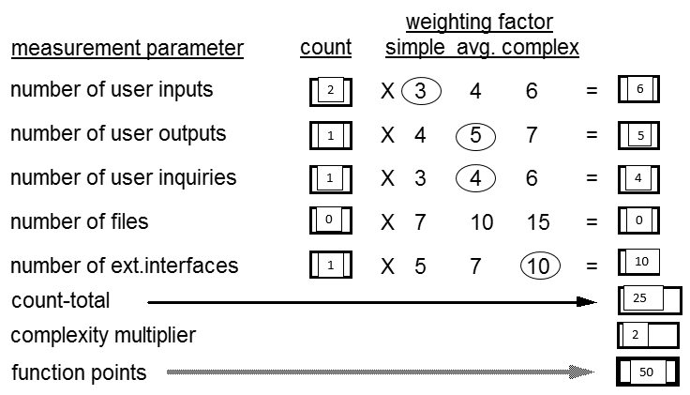

50 function points for each application, approximately translates into (50*35(for Java)) = 1750 lines of code. This was a rough approximation from our midterm report. The app now has 1206 lines of java.

Because there was no major experience with android in our group, It was hard for us to accurately count the number of lines that we could have had.

**Schedule and milestones**

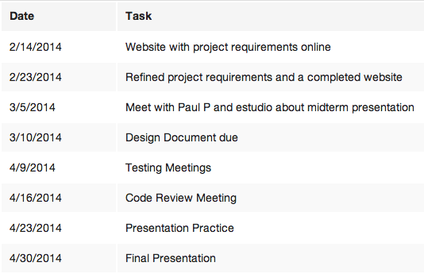

**Platforms, tools, languages**

Our devices are built to work on the Android 4.4.2 (API 19).  Lextran’s API is used to overlay the bus route information and GPS data onto the map. Google Play Services is used to allow google maps to be integrated to the Android application. We used Eclipse with the android development plugins. We used the Google maps V2 API.